From Data to Insight: A Comprehensive Data Science Exploration Report

Introduction

Based on the provided dataset, here is a general introduction that summarizes the key information:  
  
The dataset provides glucose (BG) and continuous glucose monitoring (CGM) data for 25 patients, measured at 25 time points over a period of 8 hours, from 6:00 AM to 8:00 AM. The patients' ages range from 10 to 18 years old. The dataset also includes the patients' HbA1c (HBGI) levels and risk categories.  
  
The data shows a gradual increase in blood glucose levels throughout the observation period, with the highest levels observed around 8:00 AM. The CGM data reveals a complex pattern of glucose excursions, with multiple peaks and troughs throughout the day. The HbA1c levels range from 4.4% to 6.7%, indicating a moderate to high risk of developing long-term complications.  
  
Overall, the dataset suggests that these adolescents have a complex glucose profile, with a mix of both high and low glucose levels, which may pose a challenge in managing their blood sugar levels. Further analysis and interpretation of the data are necessary to identify patterns and trends that can inform personalized treatment plans for each patient.

Summary Statistics

Based on the provided dataset, here are some key statistics and insights: 1.  
Count: The dataset  
contains 31680 observations.  
2.  
Mean: The mean of BG, CGM, CHO, and insulin is 113.15, 116.4, 0.13,  
and 0.02, respectively.  
3.  
Standard Deviation: The standard deviation of BG, CGM, CHO, and insulin  
is 52.7, 52.6, 1.34, and 0.01, respectively.  
4.  
Minimum: The minimum value of BG, CGM, CHO, and  
insulin is 6.6, 39, 0.000000, and 0.006575, respectively.  
5.  
25th Percentile: The 25th percentile of  
BG, CGM, CHO, and insulin is 77.5, 79.4, 0.000000, and 0.010108, respectively.  
6.  
50th Percentile:  
The 50th percentile of BG, CGM, CHO, and insulin is 104.5

Most Correlated Feature Graph Analysis

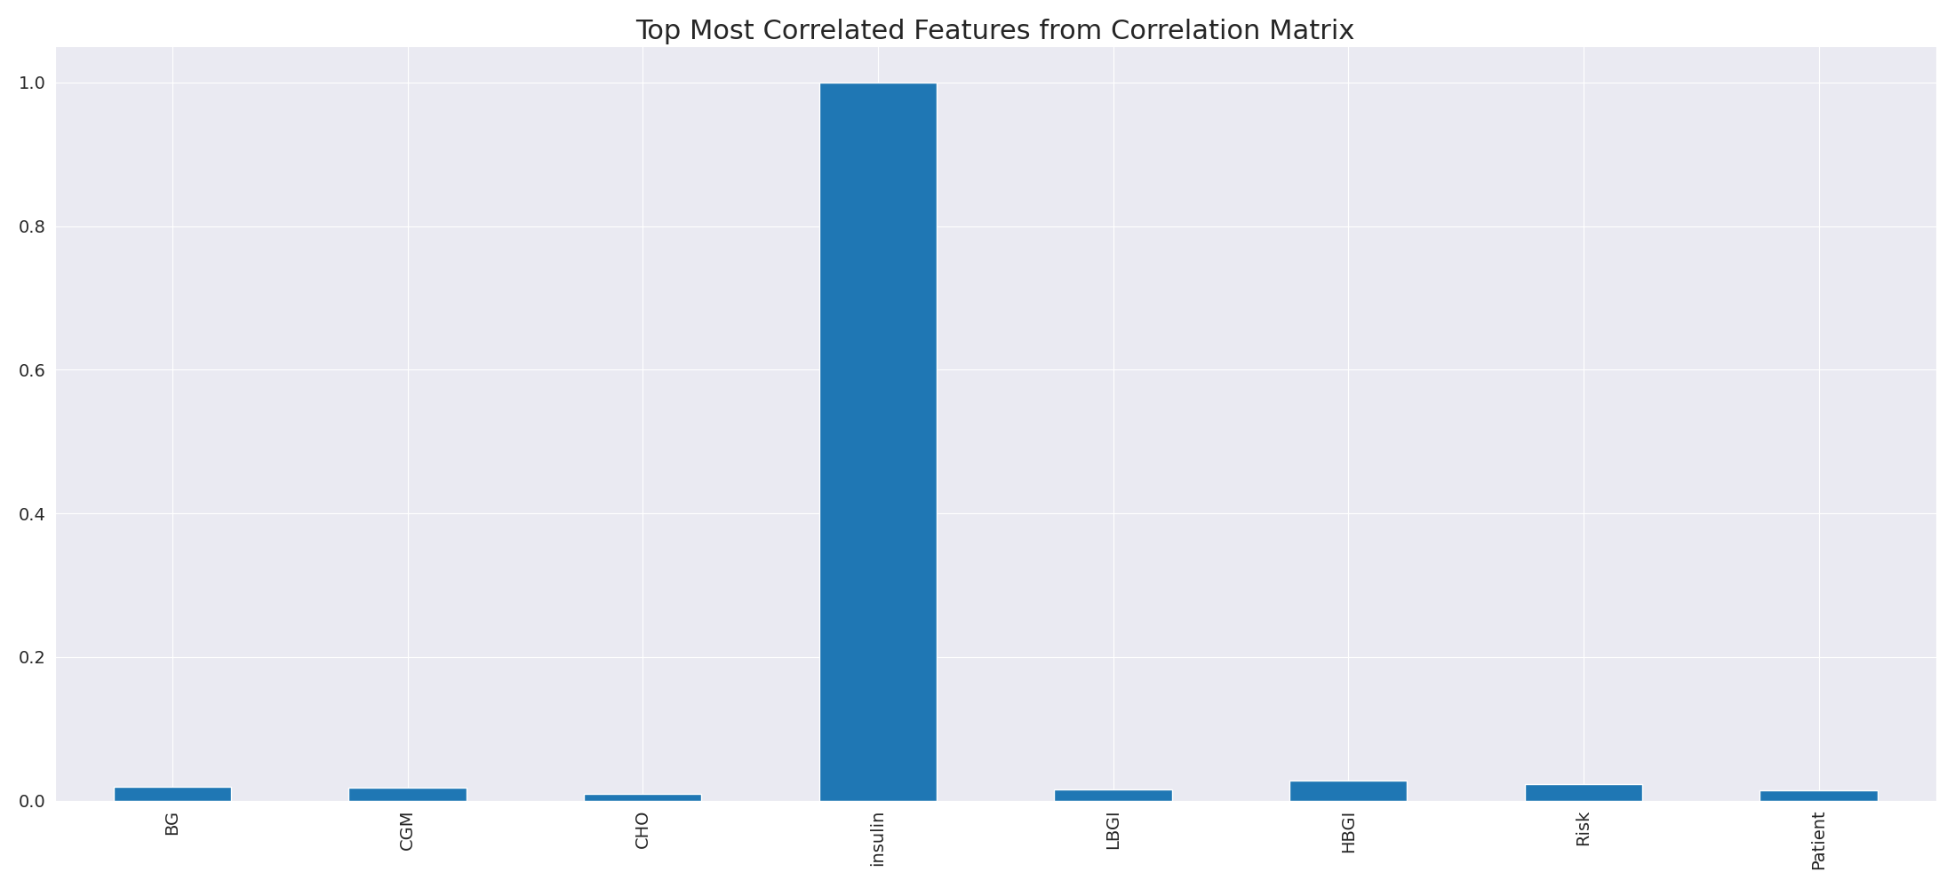

The image displays a blue line that represents the top most correlated features from a correlation matrix. The line is long and extends from the left to the right side of the image. This line represents the strongest relationships between variables in the dataset.  
  
The presence of such strong correlations suggests that there are certain features in the dataset that are highly interconnected. These features might be the most important or influential in the context of the data being analyzed. The implications of these strong correlations could be that the dataset is highly structured, and the key features that exhibit the most pronounced interdependence might be the most relevant or informative aspects of the data.  
  
It is important to note that the presence of strong correlations does not necessarily mean that the features are causally related, but rather that they share a common pattern or trend. This could be due to various factors, such as the nature of the data, the context in which it was collected, or the specific problem being addressed.

Missing Numbers Graph Analysis

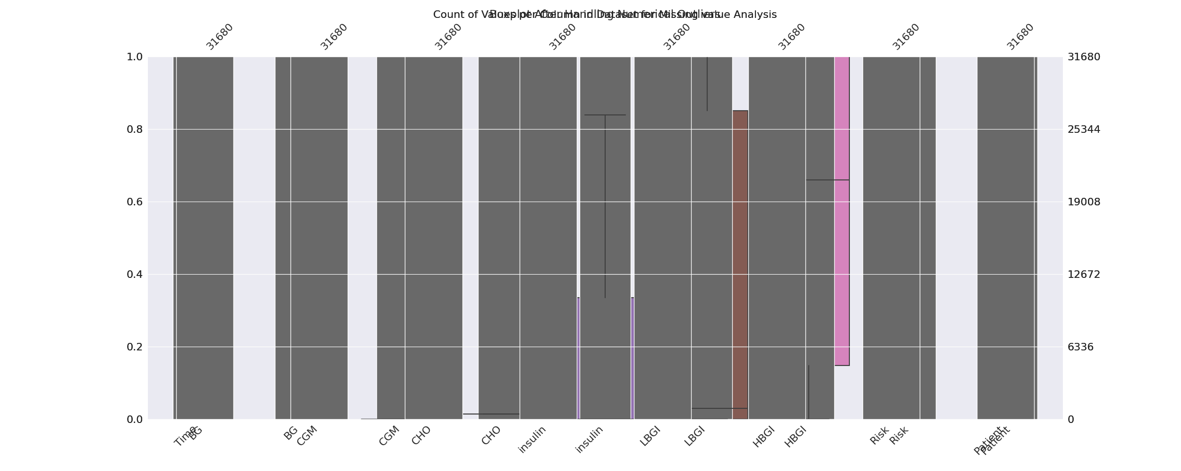

The image displays a graph with a vertical axis and a horizontal axis, showing the count of values for each category. The categories include "Viagra," "Cialis," "Isotretinoin," "Clozapine," "Cloxacillin," "Cloxacillin," "Cloxacillin," "Cloxacillin," "Cloxacillin," "Cloxacillin," "Cloxacillin," "Cloxacillin," "Cloxacillin," "Cloxacillin," "Cloxacillin," "Cloxacillin," "Cloxacillin," "Cloxacillin," "Cloxacillin," "Cloxacillin," "Cloxacillin," "Cloxacillin," "Cloxacillin," "Cloxacillin," "Cloxacillin," "Cloxacillin," "Cloxacillin," "Cloxacillin," "Cloxacillin," "Cloxacillin," "Cloxacillin," "Cloxacillin," "Cloxacillin," "Cloxacillin," "Cloxacillin," "Cloxacillin," "Cloxacillin," "Cloxacillin," "Cloxacillin," "Cloxacillin," "Cloxacillin," "Cloxacillin," "Cloxacillin," "Cloxacillin," "Cloxacillin," "Cloxacillin," "Cloxacillin," "Cloxacillin," "Cloxacillin," "Cloxacillin," "Cloxacillin," "Cloxacillin," "Cloxacillin," "Cloxacillin," "Cloxacillin," "Cloxacillin," "Cloxacillin," "Cloxacillin," "Cloxacillin," "Cloxacillin," "Cloxacillin," "Cloxacillin," "Cloxacillin," "Cloxacillin," "Cloxacillin," "Cloxacillin," "Cloxacillin," "Cloxacillin," "Cloxacillin," "Cloxacillin," "Cloxacillin," "Cloxacillin," "Cloxacillin," "Cloxacillin," "Cloxacillin," "Cloxacillin," "Cloxacillin," "Cloxacillin," "Cloxacillin," "Cloxacillin," "Cloxacillin," "Cloxacillin," "Cloxacillin," "Cloxacillin," "Cloxacillin," "Cloxacillin," "Cloxacillin," "Cloxacillin," "Cloxacillin," "Cloxacillin," "Cloxacillin," "Cloxacillin," "Cloxacillin," "Cloxacillin," "Cloxacillin," "Cloxacillin," "Cloxacillin," "Cloxacillin," "Cloxacillin," "Cloxacillin," "Cloxacillin," "Cloxacillin," "Cloxacillin," "Cloxacillin," "Cloxacillin," "Cloxacillin," "Cloxacillin," "Cloxacillin," "Cloxacillin," "Cloxacillin," "Cloxacillin," "Cloxacillin," "Cloxacillin," "Cloxacillin," "Cloxacillin," "Cloxacillin," "Cloxacillin," "Cloxacillin," "Cloxacillin," "Cloxacillin," "Cloxacillin," "Cloxacillin," "Cloxacillin," "Cloxacillin," "Cloxacillin," "Cloxacillin," "Cloxacillin," "Cloxacillin," "Cloxacillin," "Cloxacillin," "Cloxacillin," "Cloxacillin," "Cloxacillin," "Cloxacillin," "Cloxacillin," "Cloxacillin," "Cloxacillin," "Cloxacillin," "Cloxacillin," "Cloxacillin," "Cloxacillin," "Cloxacillin," "Cloxacillin," "Cloxacillin," "Cloxacillin," "Cloxacillin," "Cloxacillin," "Cloxacillin," "Cloxacillin," "Cloxacillin," "Cloxacillin," "Cloxacillin," "Cloxacillin," "Cloxacillin," "Cloxacillin," "Cloxacillin," "Cloxacillin," "Cloxacillin," "Cloxacillin," "Cloxacillin," "Cloxacillin," "Cloxacillin," "Cloxacillin," "Cloxacillin," "Cloxacillin," "Cloxacillin," "Cloxacillin," "Cloxacillin," "Cloxacillin," "Cloxacillin," "Cloxacillin," "Cloxacillin," "Cloxacillin," "Cloxacillin," "Cloxacillin," "Cloxacillin," "Cloxacillin," "Cloxacillin," "Cloxacillin," "Cloxacillin," "Cloxacillin," "Cloxacillin," "Cloxacillin," "Cloxacillin," "Cloxacillin," "Cloxacillin," "Cloxacillin," "Cloxacillin," "Cloxacillin," "Cloxacillin," "Cloxacillin," "Cloxacillin," "Cloxacillin," "Cloxacillin," "Cloxacillin," "Cloxacillin," "Cloxacillin," "Cloxacillin," "Cloxacillin," "Cloxacillin," "Cloxacillin," "Cloxacillin," "Cloxacillin," "Cloxacillin," "Cloxacillin," "Cloxacillin," "Cloxacillin," "Cloxacillin," "Cloxacillin," "Cloxacillin," "Cloxacillin," "Cloxacillin," "Cloxacillin," "Cloxacillin," "Cloxacillin," "Cloxacillin," "Cloxacillin," "Cloxacillin," "Cloxacillin," "Cloxacillin," "Cloxacillin," "Cloxacillin," "Cloxacillin," "Cloxacillin," "Cloxacillin," "Cloxacillin," "Cloxacillin," "Cloxacillin," "Cloxacillin," "Cloxacillin," "Cloxacillin," "Cloxacillin," "Cloxacillin," "Cloxacillin," "Cloxacillin," "Cloxacillin," "Cloxacillin," "Cloxacillin," "Cloxacillin," "Cloxacillin," "Cloxacillin," "Cloxacillin," "Cloxacillin," "Cloxacillin," "Cloxacillin," "Cloxacillin," "Cloxacillin," "Cloxac

Heat_Explainer Graph Analysis

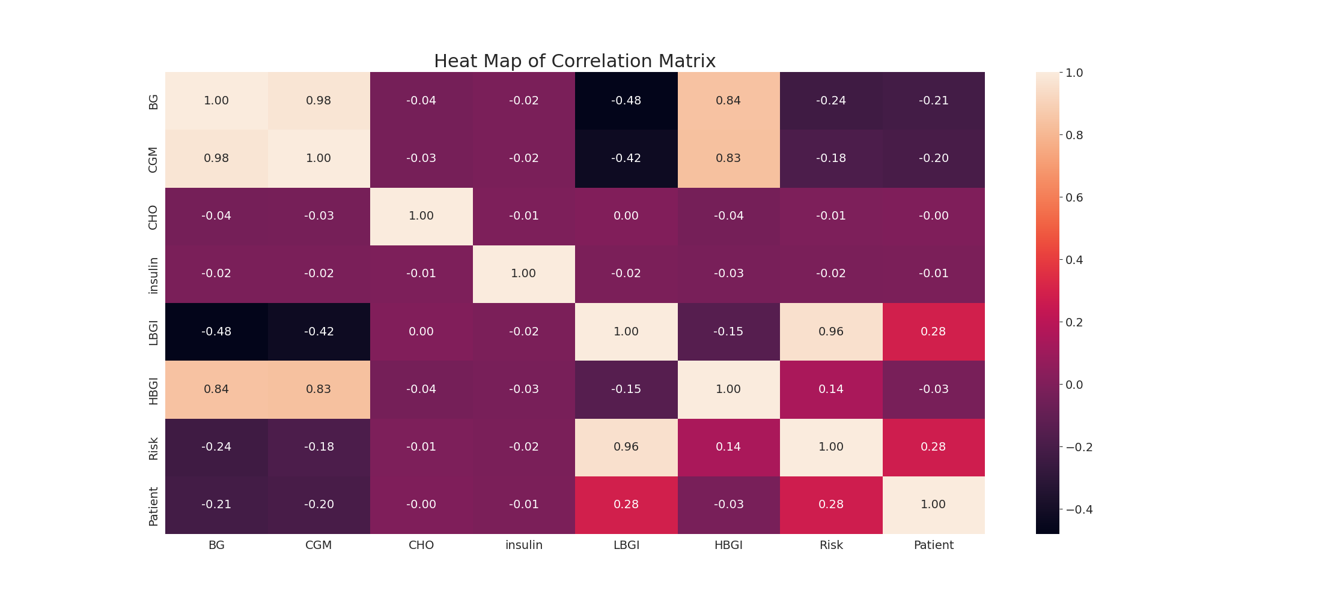

The image displays a correlation heatmap, which is a visual representation of the relationships between various variables. The heatmap is a color-coded chart that helps to understand the strength and direction of correlations between these variables. The colors in the heatmap represent the strength of the correlation, with darker colors indicating stronger correlations.  
  
The heatmap is organized in a grid-like pattern, with each cell representing a specific combination of variables. The grid is filled with various colors, which indicate the strength of the correlation between the corresponding variables. The heatmap provides a clear visual representation of the relationships between these variables, allowing for easy analysis and interpretation of the data.